

Software Engineering Department
ORT Braude College
GreenWave Project Phase A – 61998
Git link: https://github.com/MrLegiongame/GreenWave
GreenWave
25-1-D-22

Abstract
We present an optimal algorithm that will help our environment by reducing vehicles' fuel and energy consumption during daily commutes. The GreenWave project leverages adaptive traffic control technologies and data processing to dynamically adjust traffic light timings based on traffic density, vehicle types, and projected energy use. Unlike traditional systems, GreenWave minimizes energy waste and emissions while optimizing traffic flow. By incorporating advanced predictive models and user-centered design, this system offers a scalable, eco-friendly solution that integrates seamlessly into existing city infrastructure. The result is a smarter, greener traffic management system that contributes to sustainable urban development and the broader goals of energy conservation.

1. Introduction
With the world focusing more on sustainability and energy conservation, along with the growth of urban areas and increasing reliance on vehicles, it's clear we need better ways to manage traffic. Most current traffic light systems work on fixed or semi-adaptive schedules, but they often overlook important details, like the type of vehicles on the road (electric or gasoline-powered) and their different energy needs. This leads to wasted fuel or electricity, more emissions, and longer commute times, highlighting the need for smarter solutions that balance both environmental and practical needs.
The GreenWave project aims to tackle these challenges using adaptive traffic control technologies and data processing. GreenWave is designed to reduce energy use and environmental impact in a given road network by considering energy use for different vehicles and constantly changing traffic patterns. The system receives vehicles’ locations via GPS. Unlike traditional systems (such as timing traffic lights in a fixed order, and prioritizing traffic lights based on inductive loops or sensors), it adjusts traffic lights’ timing dynamically, based on factors like traffic density, vehicle types, projected fuel or electricity consumption, and optionally each vehicle’s route. This approach helps to reduce idling, stop-and-go driving, and overall energy waste.
To achieve this, GreenWave uses advanced algorithms and predictive models to create an intelligent traffic control system that can adapt to real-world conditions. This leads to direct benefits like fewer emissions and smoother traffic flow. The project also focuses on user-centered design, ensuring it can be easily scaled and integrated into existing city infrastructure. By turning old-fashioned traffic light operations into an eco-friendly, data-driven system, GreenWave is making a big contribution to the broader goals of sustainable urban growth and smarter city planning.

Algorithms that we will use (optionally) :
Dynamic programming: Define states as traffic configurations at different times. Solve sub-problems (e.g., the best route between two junctions) and combine results to minimize total fuel consumption across all vehicles. Efficiently handles overlapping sub-problems in a traffic network.
Clustering (K-means): Grouping different junctions by their calculation complexities and selecting the computation order by a certain sort decided by the clustering.
Agent-based modeling: Every junction is presented as an agent, which decides which “mode” is more efficient by its heuristic.
Flow-network: Represent junctions as nodes and roads as edges with capacities
(e.g.number of vehicles). Use maximum flow algorithms (like Ford-Fulkerson) to ensure smooth traffic flow while minimizing bottlenecks. Focus on balancing inflow and outflow to reduce waiting times and fuel consumption.
Simulating annealing: Start with an initial traffic light configuration.
Gradually adjust timings, accepting occasional suboptimal changes to escape local minima.
Iteratively cool the system to converge on a configuration that minimizes waiting times and fuel consumption.

2. Related Work
Traffic light controlling systems are essential to manage traffic flow at intersections. However, coordinating the numerous traffic lights located at nearby intersections is complicated. Dynamic traffic patterns, accidents, emergency vehicles, and pedestrian crossings influence it. Most of the time, such issues cause jams and additional congestion.

Our GreenWave project offers a solution using smart traffic management methods with data. The system monitors traffic levels and changes traffic light timings to improve flow by connecting IoT devices and sensors. The new approach aims to reduce traffic jams(as possible), save energy, and build a better and more eco-friendly city traffic system.
Traffic lights, invented in 1912, are signal devices used to control traffic flow at road intersections, pedestrian crossings, and railways, among others. They use three universal colors: green signals vehicles to proceed; yellow warns drivers to prepare to stop, and red prohibits movement[1].
Today, many countries face traffic congestion, a serious challenge for urban transport systems. From the shift from manual control by police officers and flagmen to automated traffic systems, effective heavy traffic control remains a big challenge, especially in complex intersections[2]. The rapid increase in both the number of vehicles and road users has outpaced the growth in infrastructure, which often lacks sufficient resources to meet the demand. Efforts such as new road buildings, flyovers, bypasses, and rehabilitation of existing roads have only provided partial solutions.
Traffic is quite complex due to the number of variables involved. Traffic flow changes with the time of day, peaking normally during the morning and afternoon hours. It also changes by the day of the week, as weekends usually see a decrease in traffic, while Mondays and Fridays often experience heavy congestion because people move between cities and their suburbs.
In response to these challenges, researchers from many fields work together to find pragmatic solutions for reducing congestion. New solutions are being developed, leveraging advances in microcomputers, modern devices and sensors, and algorithms specifically designed to handle the complexities of traffic systems.

[1] N. Kham, and C. Nwe, “Implementation of modern traffic light control system”, International journal of scientific and research publications, Vol. 4, Issue 6, Jun. 2014.
[2] I. Isa, N. Shaari, A. Fayeez, and N. Azlin, "Portable wireless traffic light system (PWTLS)", International journal of research in engineering and technology, Vol. 3, Issue 2, pp. 242-247, Feb 2014.

3. Background
This chapter discusses the historical development, technological advancement, and major environmental and economic issues related to traffic control systems. It illustrates the need for GreenWave as an innovative solution to improve energy efficiency, reduce emissions, and achieve sustainable urban transportation.

3.1 Development of Traffic Signal Systems
The concept of traffic signals emerged in the late 19th century as a solution to the increasing urbanization and growing number of vehicles. In 1868, the first manually operated traffic control system was created in London using gas-lit signals that a police officer operated. First, while this was an important effort toward organizing traffic flow and lessening the impact of collisions, it was clearly dangerous in reliance on manual operation and use of flammable gas.
Modern electric traffic signals, pioneered by James Hoge in 1912[3] in Cleveland, Ohio, revolutionized the management of traffic. These very first systems brought about colored lights and automated cycles into the scene—something that modern-day traffic signals build upon. Through time, enhancements in electronics and control systems further enabled semi-automated, and then fully automated, traffic lights. By the middle of the 20th century, traffic lights had been an integral infrastructure element in most cities, where vehicular and pedestrian traffic passes safely and efficiently.
Despite these advances, the primary focus of traffic light systems has remained in improving safety and relieving congestion. Even adaptive traffic control systems, which began appearing late in the 20th century and represent a vast improvement through the use of traffic information, have largely overlooked the potential for increased energy efficiency. This oversight represents a glaring hole in the current technology, and it is precisely this need that GreenWave has been developed to fill.
3.2 Energy Consumption and Environmental Impact of Urban Traffic
The rampant problem of traffic congestion in urban cities leads to a significant increase in energy consumption and environmental degradation. In conditions of idling and stop-and-go traffic—usually found in city centers with dense populations—vehicles tend to consume large amounts of fuel or electricity. These inefficiencies not only lead to increases in vehicle operating costs for their owners but also result in exceptionally high emissions of greenhouse gases (GHG) and air pollutants.
The transportation sector alone accounts for approximately 28% of the USA's total CO2 emissions, a great share being contributed by light cars[4]. Another study documented that poor traffic management increases fuel consumption by as much as 13.8%[5], thereby outlining the importance of efficient traffic systems. Although EVs are much cleaner than their gas-powered cousins, they still get less efficient in congested conditions. This revelation has provided an added impetus toward integrated solutions, which could be holistic in energy consumption.
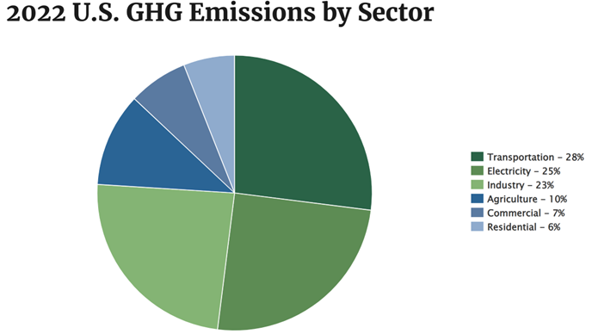
3.3 Key Concepts and Terminology
3.3.1 Adaptive Traffic Control Systems – ATCS
ATCS are defined to be systems that, based on real-time information about vehicle counts and flow rates, dynamically update the timings of traffic signals. These systems are aimed at relieving congestion and assuring a smooth flow of traffic but with few exceptions do not take into consideration the optimization of energy consumption.
3.3.2 Vehicle Energy Profiles
Vehicle energy profiles generalize the energy usage patterns of different vehicle types in varying traffic conditions. For example, ICE cars burn more fuel during idling and acceleration, while EVs waste energy through repeated start-stop cycles.
3.3.3 Sustainable Urban Mobility
This is a concept that involves transportation systems engineered to reduce environmental effects while meeting the mobility needs of urban populations. It includes measures planned to decrease energy consumption, reduce emissions, and increase the efficiency of traffic flow.

3.4 Traffic Management Technologies: Current Status
3.4.1 Traffic Simulation Instruments
Simulation packages, such as SUMO (Simulation of Urban Mobility) and PTV VISSIM, are in wide use in the field of traffic engineering for traffic flow modeling and analysis under different scenarios. Researchers can also use them to estimate the impact of alternative configurations of traffic signals on congestion, fuel consumption, and emissions.

3.4.2 Real-Time Data Collection Systems
Modern traffic management is based on various data collection technologies that include:
Loop Detectors: Sensors mounted in the road, which count and classify vehicles passing over them. They include inductive loop detectors, which detect changes in the magnetic field caused by the presence of metal in the vehicle; magnetic sensors, where a magnetic field identifies a passing vehicle; and piezoelectric sensors, which detect changes in the pressure on the road surface to determine the weight and speed of a vehicle.
Acoustic sensors, analyze sound waves generated by moving vehicles to determine their presence and characteristics.
Camera Systems: Video-based solutions that provide real-time data on traffic density and flow patterns.
GPS and Mobile Data: Devices and apps that track vehicle movements to deliver insights on traffic conditions.
These technologies, however, are somewhat limited in their integration into energy-efficient traffic management systems despite the value of the data they provide for traffic flow optimization.

3.4.3 Traffic Signal Control Algorithms
Traditional traffic light algorithms are designed mainly to maximize parameters such as throughput while minimizing delays. With recent innovations in AI and ML, today's algorithms can also embrace more parameters-namely, vehicle energy consumption and emission-within their optimization objectives.
3.5 Limitations of Existing Systems
Despite these revolutionary strides in technologies for traffic management, existing systems suffer from various limitations:
Insufficient Energy Optimization: A significant number of systems fail to optimize energy consumption specific to the vehicle in consideration, which consequently leads to either excessive fuel usage or heightened electrical costs. Inadequate Consideration of Vehicle Heterogeneity: Traffic systems typically employ a generalized strategy applicable to all vehicles, disregarding the differing levels of energy efficiency and environmental effects.
Rigid Configurations: Most of the traffic lights work on some sort of preprogrammed schedules that do not adapt to the dynamic and ever-changing nature of traffic congestion. These limitations bring about the need to develop innovative solutions that take in energy efficiency besides meeting the traditional objectives of traffic management.
3.6 Case for GreenWave
GreenWave responds to the above limitations through its data-driven, energy-efficient approach to traffic control. Using up-to-the-minute information on vehicle classifications combined with traffic density and flow dynamics, it dynamically adjusts traffic signal timing. Key features of GreenWave include: Vehicle Energy Profile Integration: GreenWave makes adjustments in traffic signals to minimize energy wastage by integrating information on fuel consumption and electrical energy.
Dynamic Adaptation: This is a analysis of traffic to optimize signal timings thus reducing idling and stop-and-go times.
Environmental Benefits: The reduction in energy consumption and emissions results in a greener environment and reduced carbon footprint.
3.7 Technological Foundations of GreenWave
3.7.1 Advanced Algorithms
GreenWave uses state-of-the-art artificial intelligence and machine-learning algorithms to analyze traffic data and predict optimal signal timings. These algorithms balance competing objectives, such as minimizing delays and reducing energy consumption.
3.7.2 Integration of the Internet of Things (IoT)
The solution integrates IoT devices—smart sensors and connected vehicles—into the collection of real-time data on traffic conditions. This collection of data allows the creation of actionable insights used in traffic signal control.
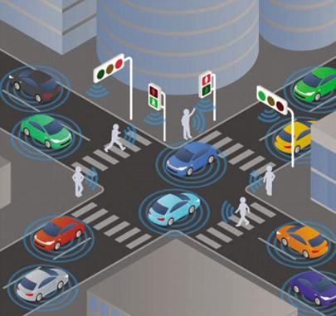
3.7.3 Scalable Architecture
GreenWave's modular design allows it to be deployed in various urban environments, from small networks of intersections to city-wide traffic systems. The system can be integrated with the existing infrastructure, therefore minimizing the costs of deployment.

3.8 Potential Impact of GreenWave
The potential impact of GreenWave is huge, and some of the benefits include:
- Energy Savings: Reduced fuel and electricity consumption across urban traffic networks.
- Environmental Improvements: Lower greenhouse gas emissions and improved air quality.
- Enhanced Mobility: Reduced travel times and congestion for commuters.
- Economic Benefits: Savings for vehicle owners and municipalities.
With its ability to address the shortcomings of existing traffic management systems, GreenWave represents a transformative approach to sustainable urban mobility.

[3] L. Clark, "Traffic signals: A brief history," Washington State University Magazine, 1994. [Online].
[4] U.S. Environmental Protection Agency, "Fast facts on transportation GHG emissions." [Online].
[5]Federal Highway Administration, "Public Roads: Red light, green light," Vol. 68, No. 3, Nov./Dec. 2004. [Online].

4. Expected Achievements
4.1 Outcomes
The GreenWave project places a strong emphasis on energy saving and environmental sustainability by increasing the efficiency of traffic light systems. By reducing idle times and eradicating unnecessary stops, our solution will help cut fuel consumption and significantly decrease greenhouse gas emissions. This will be a big step toward developing a sustainable and efficient urban setting.

To show the effectiveness of our algorithm, we will make a detailed simulation that shows traffic light adjustments under different conditions and compare the results to an excited traffic controller. It will also emphasize the potential of the algorithm in congestion reduction and improving traffic flow across several intersections.

Further, this project will evaluate the scalability and flexibility of the algorithm using simulating different urban layouts and traffic patterns. Such analysis will provide an insight into its prospective real-world implementation, demonstrating the ability of the framework to adjust to different environments and, at the same time, maintain energy efficiency.

Our study will provide a reliable framework for municipalities to implement energy-efficient traffic management solutions, thus helping to create more intelligent and sustainable urban transportation systems.

4.2 Unique Features

4.2.1 Traffic Simulation
A critical part of the project is setting up a simulation platform for demonstrating the impact of the algorithm on traffic flow. This simulation will allow us to model complex traffic situations and display the dynamic changes of traffic lights.

4.2.2 Advanced Algorithm Design
We shall design an algorithm to optimize traffic light timings at intersections based on traffic density and flow pattern information. This design will ensure a clear approach to achieving energy efficiency without affecting the smooth movement of the vehicle.

4.2.3 Scalability and Adaptability
The scalability testing on this system will imply handling varied intersection configurations, thereby leading to different characteristics across a wide range of environments that are urban by nature.
The project’s primary goal is energy savings. By minimizing vehicle idling and stop-and-go traffic, the system aims to reduce fuel consumption and emissions, supporting environmental conservation.

4.2.4 Simulation Framework
The project will include a detailed simulation framework, designed to test and validate the algorithm's performance. This framework will serve as a tool to refine and showcase the system’s capabilities in a controlled environment.

  - Criteria for Success

- A functional simulation demonstrating the algorithm's ability to optimize traffic light timings.
- Evidence of energy savings and reduced emissions in simulated scenarios.
- Clear visualization of the enhancements of traffic flow and congestion reduction.
- Algorithm's scalability validation over various intersection configurations and traffic scenarios.
- Full documentation of the simulation framework, methodology, and results

4.4. Research/Engineering Process

The process of acquiring information and learning about the GreenWave project has been divided into two main parts: conceptual understanding and practical implementation. In conceptual understanding, a lot of effort has been placed on understanding the dynamics of traffic flow, patterns of energy consumption, and ecological consequences associated with the current traffic light system. From a pragmatic point of view, the program looks into the integration of advanced algorithms, sensor networks, and data analytics with the pre-existing traffic light systems in urban environments in order to enhance traffic flow and reduce fuel or energy consumption. This two-way approach ensures complete understanding and implementation of the technology to effectively achieve the goals of the project.

5. The Process
5.1 Research – Traffic Management Systems
As we worked on expanding our knowledge in the area of traffic management systems optimization, the following questions were considered:
• Inefficiencies associated with current traffic light systems as relates to the reduction of energy consumption and emissions.[6]
• How one might factor in traffic density and vehicle type in terms of electric versus gasoline-powered versus gas-powered into the design of an efficient control system.[7,8]
• Description of the adaptive technologies and algorithms currently in existence for traffic light optimization.[7]
• How reliable, scalable, and environmentally impactful these systems are when deployed in real-world urban environments.[8]
In response to these questions and as a way to enhance our understanding, we conducted a wide-based review of literature, technical reports, and simulation studies. This involved a review of reinforcement learning algorithms, energy consumption models, and optimization methods in the context of urban traffic systems.[6,7,8] From the reviewed documents, our team convened for discussion on the findings and to lay down key objectives that needed to be met in the development of GreenWave. The research entailed several findings, including:
• The vehicle energy profiles should be integrated so that the unnecessary consumption of fuel or electricity can be reduced.[6,8]
• Adaptive signal systems need to consider dynamic traffic conditions in terms of density and flow patterns to effectively reduce idle times and stop-and-go traffic.[7,8 ]
• Real-time data collection and analysis can significantly enhance the accuracy and responsiveness of traffic light control systems.[7]
These were the building blocks in developing a system that focuses on energy efficiency, reduction in environmental impact, and optimization of urban mobility.

5.1.1 Constraints and Challenges – Traffic Management Systems
One of the most critical challenges in developing GreenWave was the multi-faceted nature of urban traffic systems. Some of the key constraints were:
1. Dynamic Adaptation: Development of algorithms that could function in to the fluctuating traffic condition without complicating or delaying computational resources.[7,8]
2. Vehicle Diversity: Accounting for differing energy consumption patterns between electric and internal combustion vehicles.[6,8]
3. System Scalability: Ensuring the solution’s effectiveness across both small intersections and large city-wide networks. [6,8]
4. Environmental Metrics: Integrating measurable outcomes like fuel savings and emission reductions into the optimization framework. [6,8]
5.1.2 Conclusions from Research – Inspiration for GreenWave
The conclusions drawn from addressing these challenges were influenced by studies on adaptive traffic systems and energy models. [7,8] They also demonstrated how reinforcement learning traffic optimization can be quite effective in lowering vehicle delay and energy use—especially when supported by simulations on a SUMO platform, showing great potential in reducing travel times and emissions by adaptive signal control.[7] While SUMO is a good source of lessons and tools that can be borrowed for traffic simulation, the software being developed by GreenWave will be built from scratch but inspired in part by ideas from SUMO, but shall not be used directly. [7,8]

5.2 Research – Simulation and Optimization Tools
As part of the development going on regarding tools and technologies that shall be required to build GreenWave, some of the research it is currently handling includes (first and second in Hardware are required only for real-world implementations):
Hardware:
• Role of IoT sensors in gathering real-time traffic data.
• Integration of GPS devices for the tracking of vehicle density and movement.
• Computational infrastructure requirement for large-scale simulation performance.
Software:
• Principles of traffic simulation, like those developed in SUMO, were reviewed to design our customized one.
• Design of reinforcement learning and optimization algorithm.
• Integration of rolling resistance models to estimate energy consumption based on vehicle and road parameters.
In developing a robust and practical simulation framework, we borrowed much from previous work outlining successful traffic light optimization strategies; these included, in order to address the problem, the application of reinforcement learning algorithms dynamically updating the traffic lights, to genetic algorithms increasing the reliability of the system based on various types of traffic flows.

5.2.1 Constraints and Challenges – Simulation and Optimization
Simulation Accuracy:
Ensuring that simulation scenarios realistically modeled real-world traffic conditions was a key challenge—any inaccuracies could translate to inefficiencies or inaccuracies in optimization results.
Computational Constraints:
The trade-off between the demand for detailed, high-fidelity simulations and the practical limitations of available processing power led to iterative system architecture refinement.
Intersection Coordination:
Designing coordinated signal timing across multiple intersections—to create seamless green waves without causing bottlenecks—became a very complex optimization problem.
5.3 Methodology and Development Process
For development, we have chosen an agile methodology that proved to be well-suited for our iterative process. Working in cycles allowed us to incrementally develop and refine GreenWave with maximum flexibility for adjustments. The development process was divided into the following phases:
1. Setting up the simulation environment: Designing a custom traffic simulation platform inspired by SUMO to model urban scenarios.
2. Algorithm development: Reinforcement learning and optimization techniques in signal control.
3. Data Generation: Real-world traffic generation based on a real-world scenario
4. Energy Modeling: Estimating energy consumption using rolling resistance calculations.
5. Testing and Refinement: The developed system should be iteratively tested using simulated scenarios with an evaluation of the defined performance metrics and making adjustments if necessary.
Testing was carried out at each iteration to find and resolve any possible problems. Such an iterative process made sure that not only would GreenWave meet its goals, but it would also be responsive to user feedback and dynamic urban traffic needs.
Reference Mapping:
6. Energy Efficiency and Urban Traffic Models: Mojtaba Ziyadi, Hasan Ozer, Seunggu Kang, Imad L. Al-Qa. (2017). "Vehicle energy consumption and an environmental impact calculation model for the transportation infrastructure system". Department of Civil and Environmental Engineering, University of Illinois at Urbana-Champ.
7. Adaptive Traffic Light Control Systems and Reinforcement Learning: Marco Wiering, Jelle van Veenen, Jilles Vreeken, Arne Koopman. (2004). "Intelligent Traffic Light Control"​. Intelligent Systems Group. Institute of Information and Computing Sciences Utrecht University.
8. Energy Modeling and Simulation Tools: Ferrer, J., Lopez-Ibanez, M., & Alba, E. (2019). "Reliable Simulation-Optimization of Traffic Lights in a Real-World City". Applied Soft Computing.

6. Product

6.1 Requirements

Functional:
1 | The system dynamically adjusts traffic light timings based on traffic density and vehicle profiles
2 | The system shall have a dedicated local app
3 | The system can save and load parameters
4 | The system has differentiated between vehicle types (e.g., EVs vs. gas-powered) to apply specific energy-saving strategies
5 | The system analyzes data and produces an analysis report

Non-functional:
1 | Easy-to-use graphical interface for the user
2 | Supports deployment from single intersections to city-wide networks
3 | Achieves measurable reductions in carbon footprint and urban air pollution
4 | Supports easy updates and debugging to ensure long-term operation
5 | Simple interaction mechanism

6.2 Architecture overview
- UI application.
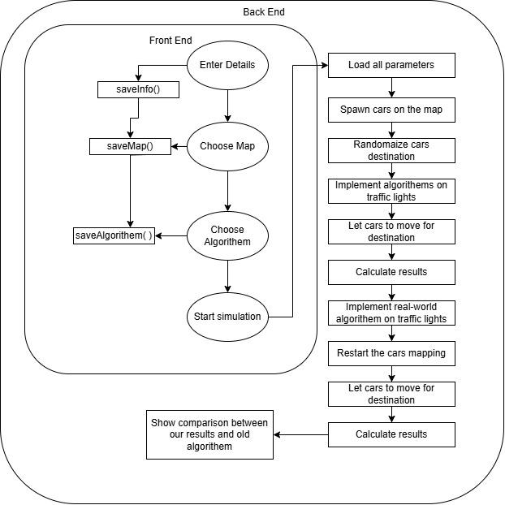
Figure 5: Architecture scheme

Our UI application consists of two layers:
- Front end
- Back end

The following figures show and explain the application (not yet the final product, though the same functionalities):
6.2.1 Main screen
That’s the screen presented when starting the software and after each simulation:
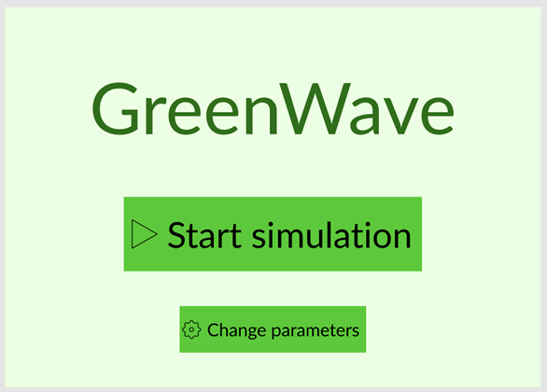
Figure 6: Main menu screen
The button "Start simulation" can be pressed and then the screen in Simulation screen is presented.
The button "Change parameters" can be pressed and then the screen in Settings screen (1) is presented.

6.2.2 Settings
In this screen, the user can change the settings of the simulation before running it.
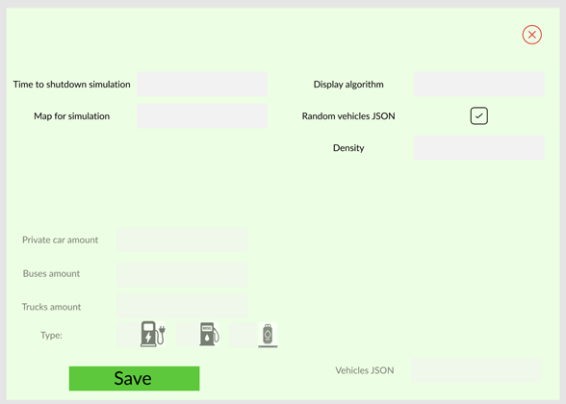
Figure 7: Settings screen (1)

In "Time to shut down simulation" the user chooses for how long he wants the simulation to run (in minutes).
In "Maps for simulation" the user chooses a map from a list of premade maps.
In "Display algorithm" the user chooses from a list which algorithm the simulation will be based on while running.
In "Random vehicles JSON" the user can choose wether he wants a random set of vehicles in the simulation.
In "Density" the user chooses the degree of the density of the randomness: "High density"/ "Average density"/ "Low density".
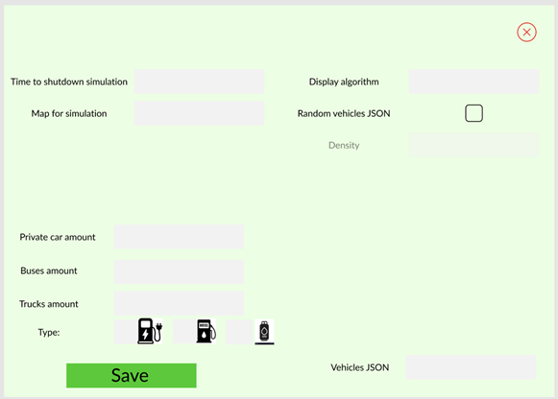
Figure 8: Settings screen (2)
In "Private car amount", "Buses amount", and "Trucks amount", the user chooses how many vehicles he wants from each kind and the overall energy consumption type for all of the vehicles in the simulation.
In "Vehicles JSON" the user can configure a JSON file compatible for the simulation's vehicle information. Includes attributes such as: Engine type, Weight, Energy consumption type, and so forth.
The red "X" button in the top-right corner can be pressed in order to go to the main menu without saving the changes.
The "Save" button can be pressed to go to the main menu to save the changes.

6.2.3 Interfaces and Simulation Flow
In this screen, we have a simulation running based on the parameters saved in the Settings screen.
The simulation displays an overview of the entire map while the vehicles drive around and the algorithm chosen in the Settings screen is the algorithm that controls the traffic lights, and in fact is the cause for the statistics data in the Statistics report screen.
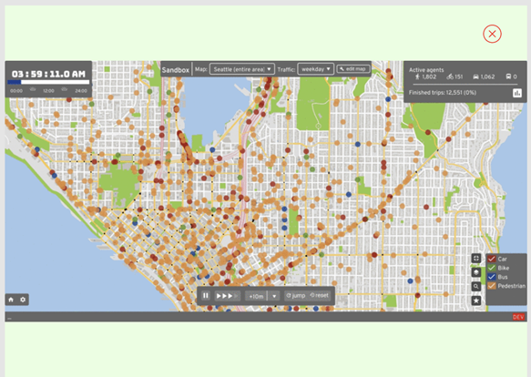
Figure 9: Simulation screen

The red "X" button in the top-right corner can be pressed to go to the screen presented in the Statistics report screen, (you can wait until the simulation ends either).

6.2.4 Data Storing and Handling
The software allows to store data just as described in 6.2.2 and 6.2.5
To present and analyze our data there will be a need for an easy-to-use interface.
6.2.5 Data Analysis and Classification
In this screen, we have a statistics dashboard based on the simulation's results.
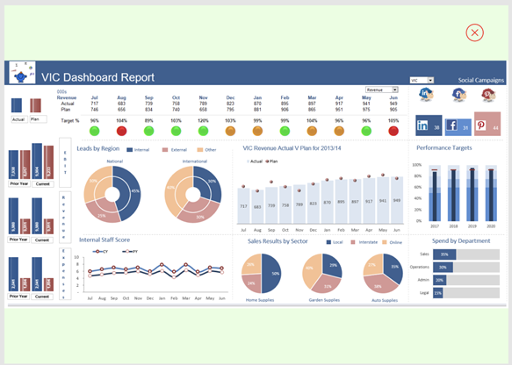
Figure 10: Statistics report screen
The red "X" button in the top-right corner can be pressed to go to the main menu screen.
There's a button to download locally the data to the data file.

6.3 Diagrams

6.3.1 Use Case
The following Use Case diagram shows both the user
Interaction with the system.

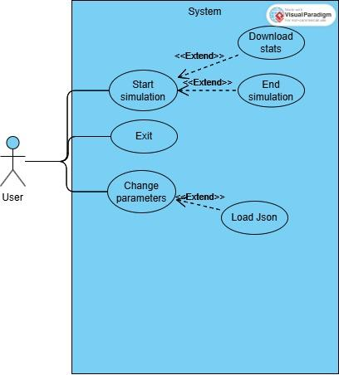

Figure 16: Use Case diagram

6.3.2 Sequence Diagram
This sequence diagram shows the logical flow between the user and program while changes parameters and run simulation

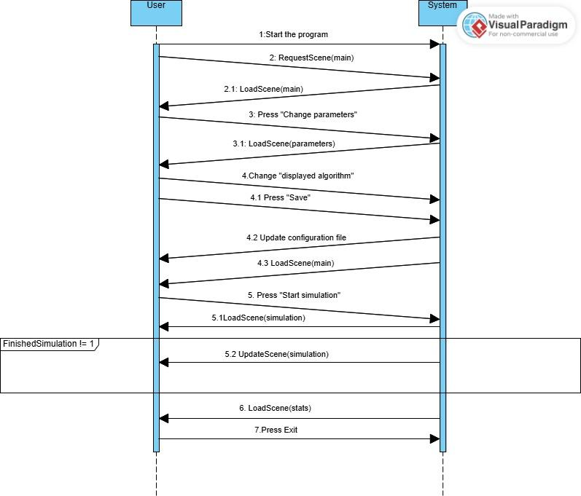

6.3.3 Activity Diagram
The following Activity diagram shows the whole process from when the user enters the program until the statistics data is ready and can be shown and downloaded.

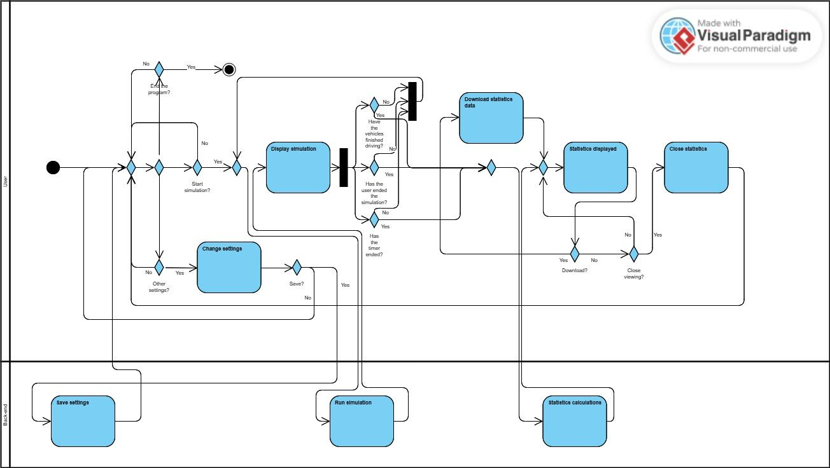
Figure 17: Activity diagram

7. Verification and Evaluation

7.1 Evaluation

The performance of the GreenWave plan will be measured by how effectively it improves traffic throughput, reduces time vehicles spend waiting, and reduces overall energy consumption. These factors will be compared using live simulations and controlled tests simulating a variety of urban traffic conditions.

The main measure of evaluation will be the percentage reduction in fuel usage and emissions versus conventional traffic light systems. Secondary measures will be the average time stopped per vehicle, the percentage of seamless transitions from green to green, and the overall efficiency of traffic movement through intersections.

Furthermore, the algorithm will be tested on how well it can balance the demands of various classes of vehicles (e.g., electric, internal combustion engines) and how well it can adapt to respond to unforeseen traffic situations like accidents or abrupt increases in congestion.

Our goal with this project is to implement a system that achieves significant environmental gains and optimizes traffic control while being scalable and easy to integrate with current urban infrastructure.

7.2 Verification

Verification of GreenWave will focus on ensuring that the system works as intended under various scenarios. Key steps in the verification process include:
- Algorithm Validation: Simulations will ensure that the algorithms accurately forecast and adjust traffic light cycles to achieve optimal traffic throughput and reduce energy consumption.

- Environmental Metrics:We will make sure that the system does, in fact, cut fuel use and emissions in quantifiable terms.
- Easy Navigation: Provide all screens with easy navigation and working buttons.
- Verify that the proper error messages are displayed for erroneous inputs (i.e., a malformed JSON upload).
- Ease of Use Interface: Provide easily editable settings and simulation options.
- Data Visualization: Make the statistics and simulation results clear, accurate, and easy to understand.

7.3 Testing Plan
Since GreenWave is to be deployed in phases, the testing will be done in three phases: Traffic Simulation, Algorithm Optimization, and System Integration. Each of the phases will undergo proper unit and system-level testing to ensure it is working as expected and is stable.

Test | Module | Tested Function | Expected Result
1 | Algorithm Optimization | Fuel consumption minimization | Reduction in energy consumption > 15%
2 | Algorithm Optimization | Emissions reduction | Reduction in emissions > 10%
3 | Algorithm Optimization | Vehicle type differentiation | System accounts for fuel and electric vehicles
4 | Environmental Metrics | Reporting fuel and emissions savings | Accurate calculation and reporting of savings
5 | Main Screen | "Start Simulation" button | Navigates to the simulation screen when pressed
6 | Main Screen | "Change Parameters" button | Navigates to the settings screen when pressed
7 | Settings Screen | "Time to Shut Down Simulation" field | Correctly sets simulation duration in minutes
8 | Settings Screen | "Maps for Simulation" dropdown | Displays and selects from a list of preloaded maps
9 | Settings Screen | "Vehicle JSON" file upload | Uploads and validates a JSON file for vehicle data
10 | Simulation Screen | Real-time map overview | Displays map and vehicles moving based on parameters and map rules
11 | Simulation Screen | Statistics generation during simulation | Tracks and updates data for the statistics screen
12 | Statistics Screen | Statistics dashboard | Accurately displays simulation results in graphs/charts
13 | Statistics Screen | Data download button | Successfully downloads simulation data to a local file
14 | Statistics Screen | "X" button | Navigates back to the main menu
15 | Simulation | Traffic Light Logic Testing | Green - go  Yellow - prepare to stop  Red - stop
16 | Simulation | Vehicle Behavior Testing | Vehicles stop at red lights  No vehicles get stuck at intersections or block traffic due to faulty decision-making.
17 | Simulation | Route & Traffic Flow Testing | Vehicles take the shortest or most efficient route based on real-time traffic conditions.
18 | Simulation | Map & Environment Testing | The road layout is accurate and matches the intended test case (e.g., city streets, highways, intersections)
19 | Algorithm | Adaptive Algorithm Testing | Traffic light durations change dynamically based on vehicle flow
20 | Algorithm | Multi-Intersection Synchronization | Vehicles traveling along main roads encounter synchronized green lights, reducing unnecessary stops

8. References
[1] N. Kham, and C. Nwe, “Implementation of modern traffic light control system”, International journal of scientific and research publications, Vol. 4, Issue 6, Jun. 2014.
[2] I. Isa, N. Shaari, A. Fayeez, and N. Azlin, "Portable wireless traffic light system (PWTLS)", International journal of research in engineering and technology, Vol. 3, Issue 2, pp. 242-247, Feb 2014.
[3] L. Clark, "Traffic signals: A brief history," Washington State University Magazine, 1994. [Online].
[4] U.S. Environmental Protection Agency, "Fast facts on transportation GHG emissions." [Online].
[5]Federal Highway Administration, "Public Roads: Red light, green light," Vol. 68, No. 3, Nov./Dec. 2004. [Online].
[6] Mojtaba Ziyadi, Hasan Ozer, Seunggu Kang, Imad L. Al-Qa. (2017). "Vehicle energy consumption and an environmental impact calculation model for the transportation infrastructure system". Department of Civil and Environmental Engineering, University of Illinois at Urbana-Champ.
[7] Marco Wiering, Jelle van Veenen, Jilles Vreeken, Arne Koopman. (2004). "Intelligent Traffic Light Control"​. Intelligent Systems Group. Institute of Information and Computing Sciences Utrecht University.
[8] Ferrer, J., Lopez-Ibanez, M., & Alba, E. (2019). "Reliable Simulation-Optimization of Traffic Lights in a Real-World City". Applied Soft Computing.

